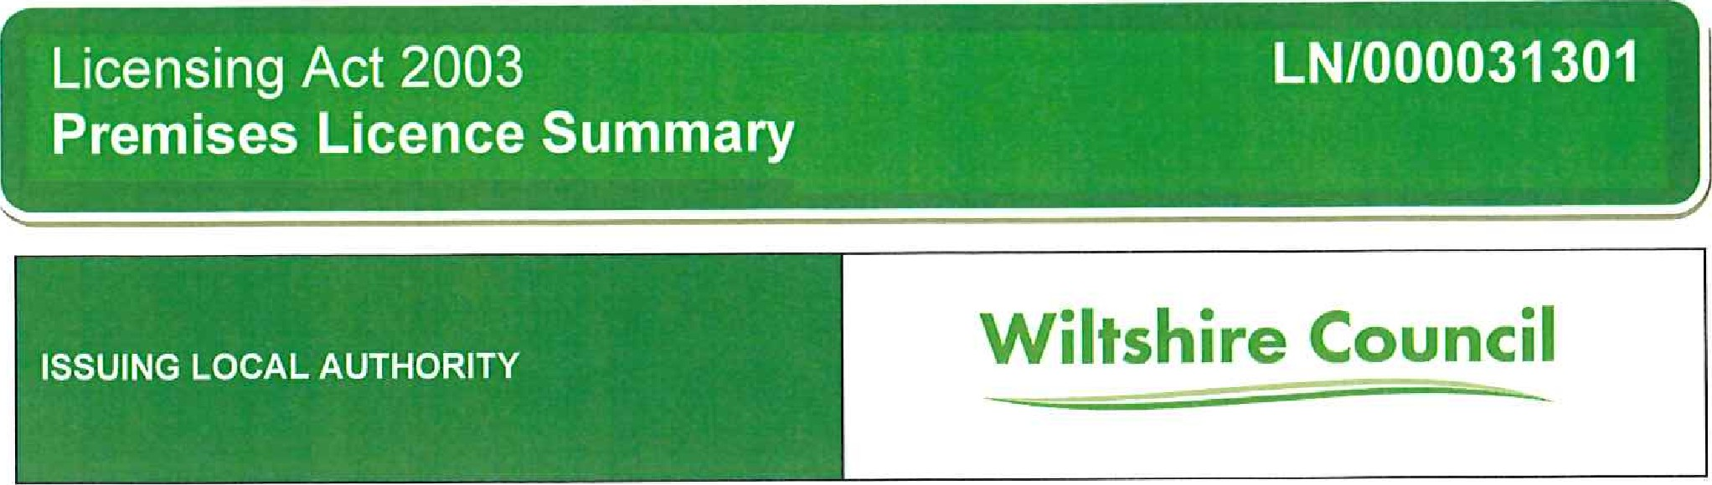
PART 1 PREMISES LICENCE SUMMARY & LICENCE HOLDER DETAILS
POSTAL ADDRESS OF PREMISES, OR IF NONE, ORDNANCE SURVEY MAP REFERENCE OR DESCRIPTION
The Bridge Inn, Horton Road, Devizes, Wiltshire, SNIO 2JS
NAME, (REGISTERED) ADDRESS AND CONTACT DETAILS OF HOLDER OF PREMISES LICENCE
Wadworth & co LTD
Folly Road Brewhouse, Folly Road Brew House, Folly Road, Devizes, Wiltshire, SNIO 2HT Email: helenlawrence@wadworth.co.uk
REGISTERED NUMBER OF HOLDER, FOR EXAMPLE COMPANY NUMBER, CHARITY NUMBER 
30177
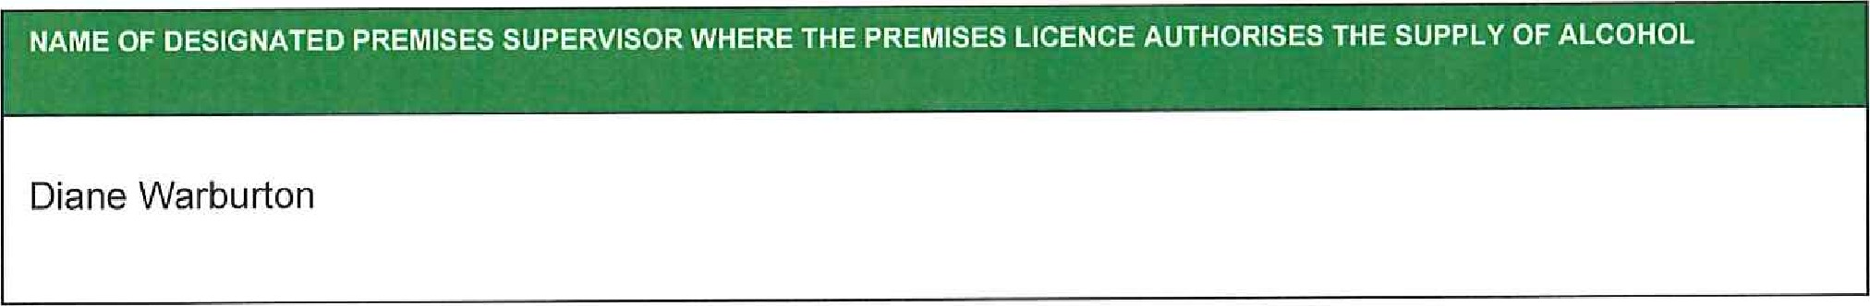
ISSUING AUTHORITY AND PERSONAL LICENCE NUMBER HELD BY DESIGNATED PREMISES SUPERVISOR WHERE THE PREMISES LICENCE AUTHORISES FOR THE SUPPLY OF ALCOHOL
Swindon Borough Council 24/0047/LlPER
WHERE THE LICENCE IS TIME LIMITED - THE DATES AND TIMES  
Not Applicable
WHERE THE LICENCE AUTHORISES SUPPLIES OF ALCOHOL WHETHER THESE ARE ON AND 1 OR OFF SUPPLIES 
ON & OFF Sales
STATE WHETHER ACCESS TO THE PREMISES BY CHILDREN IS RESTRICTED OR PROHIBITED
Where applicable the provisions of Section 145 of the Licensing Act 2003 apply
PART 2 - LICENSABLE ACTIVITIES & TIMINGS
LICENSABLE ACTIVITIES AUTHORISED BY THE LICENCE
Licensable activities |  | Location |  | Day |  | Time From |  | Time To |  | Time From |  | Time To
Alcohol Sales |  | ON and OFF Sales |  | Sunday |  | 10:00 |  | 00:00
 |  |  |  | Monday |  | 10:00 |  | 00:00
 |  |  |  | Tuesday |  | 10:00 |  | 00:00
 |  |  |  | Wednesday |  | 10:00 |  | 00:00
 |  |  |  | Thursday |  | 1 0:00 |  | 00:00
 |  |  |  | Friday |  | 1 0:00 |  | 00:00
 |  |  |  | Saturday |  | 10:00 |  | 00:00
Non-Standard Timings  & Seasonal Variations |  | New Years Eve 10'00hrs to 00:00hrs on January 1st
Alcohol Sales |  | ON & OFF Sales Outside |  | Sunday |  | 10:00 |  | 21:00
 |  |  |  | Monday |  | 10:00 |  | 21.00
 |  |  |  | Tuesday |  | 10:00 |  | 21
 |  |  |  | Wednesday |  | 10:00 |  | 21 .•oo
 |  |  |  | Thursday |  | 10:00 |  | 21 00
 |  |  |  | Friday |  | 10:00 |  | 21 00
 |  |  |  | Saturday |  | 10:00 |  | 21.00
Non-Standard Timings
& Seasonal Variations
Live Music  Recorded Music  Similar to any Music or  Dance  Facilities for dancing |  | Indoors |  | Sunday |  | 10:00 |  | 23:00
 |  |  |  | Monday |  | 10:00 |  | 23:00
 |  |  |  | Tuesday |  | 10:00 |  | 23:00
 |  |  |  | Wednesday |  | 1 0:00 |  | 23:00
 |  |  |  | Thursday |  | 1 0:00 |  | 2300
 |  |  |  | Friday |  | 1 0:00 |  | 2300
 |  |  |  | Saturday |  | 1 0:00 |  | 2300
Non-Standard Timings  & Seasonal Variations |  | New Year's Eve 10:00hrs to 02:00hrs on January 1st
 | Late Night Refresh |  | Indoors |  | Sunday |  | 23:00 |  | 00:00
 |  |  |  |  | Monday |  | 23,00 |  | 00:00
 |  |  |  |  | Tuesday |  | 23:00 |  | 00:00
 |  |  |  |  | Wednesday |  | 23:00 |  | 00:00
 |  |  |  |  | Thursday |  | 23:00 |  | 00:00
 |  |  |  |  |  |  | 23.00 |  | 00:00
 |  |  |  |  | Saturday |  | 23:00 |  | 00:00
 | Non-Standard Timings  & Seasonal Variations |  | New Year's Eve 23:00hrs to 00:00hrs on January 1st
 | Hrs premises open to |  |  |  | Sunday |  | 10:00 |  | 01
 |  |  |  |  | Monday |  |  |  | 01
 |  |  |  |  | Tuesday |  | 1 0•.oo |  | 01
 |  |  |  |  | Wednesday |  | IO•OO |  | 01
 |  |  |  |  | Thursday |  | 10:00 |  | 01
 |  |  |  |  | Friday |  | 10:00 |  | 01
 |  |  |  |  | Saturday |  | 10:00 |  | 01
 | Non-Standard Timings  & Seasonal Variations |  | New Year's Eve 10:00hrs to 01 :00hrs on January 2nd
Licence Commencement Date
24th June 2005

Licensing Officer
Last Amendment Date
22nd February 2024

Licensing Officer
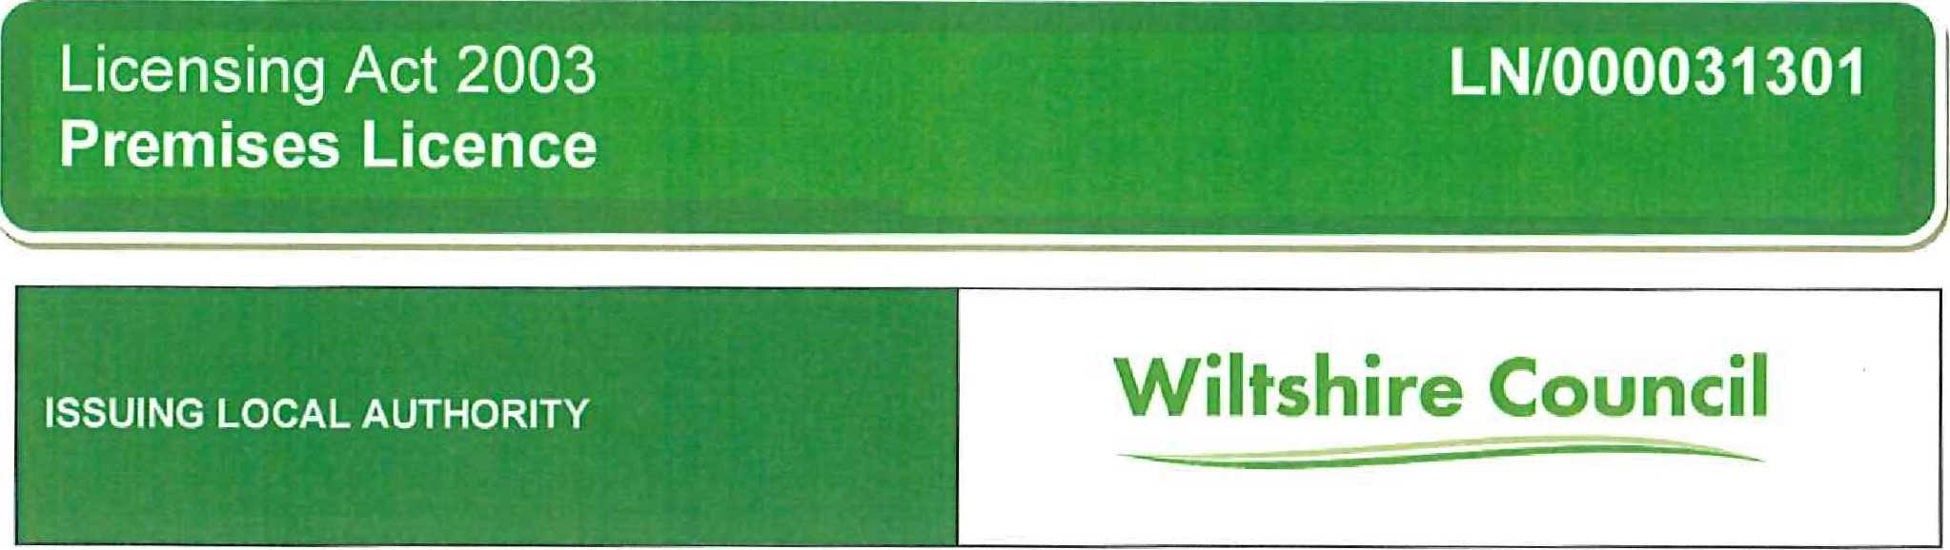
PART 1 - PREMISES & LICENCE HOLDER DETAILS
POSTAL ADDRESS OF PREMISES, OR IF NONE, ORDNANCE SURVEY MAP REFERENCE OR DESCRIPTION
The Bridge Inn, Horton Road, Devizes, Wiltshire, SNIO 2JS
NAME, (REGISTERED) ADDRESS AND CONTACT DETAILS OF HOLDER OF PREMISES LICENCE
Wadworth & co LTD
Folly Road Brewhouse, Folly Road Brew House, Folly Road, Devjzes, Wiltshire, SNIO 2HT Email: helenlawrence@wadworth.co.uk
REGISTERED NUMBER OF HOLDER, FOR EXAMPLE COMPANY NUMBER, CHARITY NUMBER  
30177
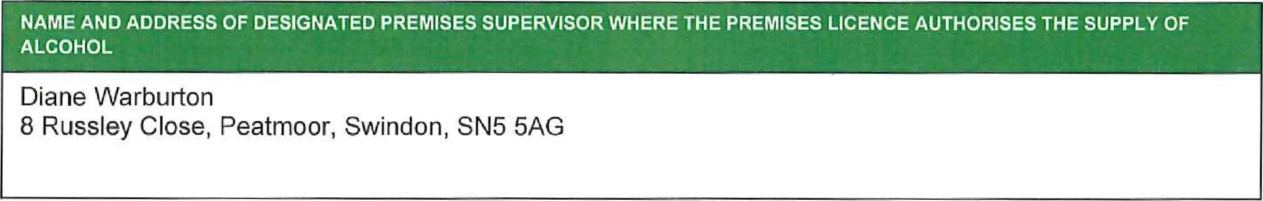
ISSUING AUTHORITY AND PERSONAL LICENCE NUMBER HELD BY DESIGNATED PREMISES SUPERVISOR WHERE THE PREMISES LICENCE AUTHORISES FOR THE SUPPLY OF ALCOHOL
Swindon Borough Council 24/0047/LlPER
WHERE THE LICENCE IS TIME LIMITED - THE DATES AND TIMES
Not Applicable
WHERE THE LICENCE AUTHORISES SUPPLIES OF ALCOHOL WHETHER THESE ARE ON AND 1 OR OFF SUPPLIES
ON & OFF Sales
STATE WHETHER ACCESS TO THE PREMISES BY CHILDREN IS RESTRICTED OR PROHIBITED
Where applicable the provisions of Section 145 of the Licensing Act 2003 apply
PART 2 - LICENSABLE ACTIVITIES & TIMINGS
 | LICENSABLE ACTIVITIES AUTHORISED BY THE LICENCE
 | Licensable activities |  | Location |  | Day |  | Time From |  | Time To |  | Time From |  | Time To
 | Alcohol Sales |  | ON and OFF Sales |  | Sunday |  | 10:00 |  | 00:00
 |  |  |  |  | Monday |  | 10:00 |  | 00:00
 |  |  |  |  | Tuesday |  | 10:00 |  | 00:00
 |  |  |  |  | Wednesday |  | 10:00 |  | 00:00
 |  |  |  |  | Thursday |  | 10:00 |  | 00:00
 |  |  |  |  | Friday |  | 10:00 |  | 00:00
 |  |  |  |  | Saturday |  | 10:00 |  | 00:00
 | Non-Standard Timings  & Seasonal Variations |  | New Years Eve 10:00hrs to 00:00hrs on Januay 1st
 | Alcohol Sales |  | ON & OFF Sales Outside |  | Sunday |  | 10:00 |  | 21.00
 |  |  |  |  | Monday |  | 1 0:00 |  | 21100
 |  |  |  |  | Tuesday |  | 10:00 |  | 21 00
 |  |  |  |  | Wednesday |  | 10:00 |  | 21:00
 |  |  |  |  | Thursday |  | 1 0:00 |  | 21.00
 |  |  |  |  | Friday |  | 10:00 |  | 21
 |  |  |  |  | Saturday |  |  |  | 21
Non-Standard Timings
& Seasonal Variations
 | Live Music  Recorded Music  Similar to any Music or  Dance  Facilities for dancing |  | Indoors |  | Sunday |  | 10:00 |  | 23:00
 |  |  |  |  | Monday |  | 10:00 |  | 23:00
 |  |  |  |  | Tuesday |  | 1 0:00 |  | 23:00
 |  |  |  |  | Wednesday |  | 10:00 |  | 23:00
 |  |  |  |  | Thursday |  | 10:00 |  | 23:00
 |  |  |  |  | Friday |  | 10:00 |  | 23:00
 |  |  |  |  | Saturday |  | 10:00 |  | 23:00
 | Non-Standard Timings  & Seasonal Variations |  | New Year(s Eve 10:00hrs to 02:00hrs on January 1st
Late Night Refresh |  | Indoors |  | Sunday |  | 23:00 |  | 00:00
 |  |  |  | Monday |  | 23:00 |  | 00:00
 |  |  |  | Tuesday |  | 23:00 |  | 00:00
 |  |  |  | Wednesday |  | 23:00 |  | 00:00
 |  |  |  | Thursday |  | 23:00 |  | 00:00
 |  |  |  |  |  | 23:00 |  | 00:00
 |  |  |  | Saturday |  | 2300
Non-Standard Timings  & Seasonal Variations |  | New Year's Eve 23:00hrs to 00:00hrs on January 1st
Hrs premises open to |  |  |  | Sunday |  | 10:00 |  | 01
 |  |  |  | Monday |  | 10:00 |  | 01
 |  |  |  | Tuesday |  |  |  | 01:00
 |  |  |  | Wednesday |  | 10:00 |  | 01
 |  |  |  | Thursday |  | 10:00 |  | 01
 |  |  |  | Friday |  | 10:00 |  | 01
 |  |  |  | Saturday |  | 10:00 |  | 01
Non-Standard Timings  & Seasonal Variations |  | New Year's Eve 10:00hrs to 01 :00hrs on January 2nd
Licence Commencement Date
24th June 2005

Licensing Officer
Last Amendment Date
22nd February 2024

Licensing Officer
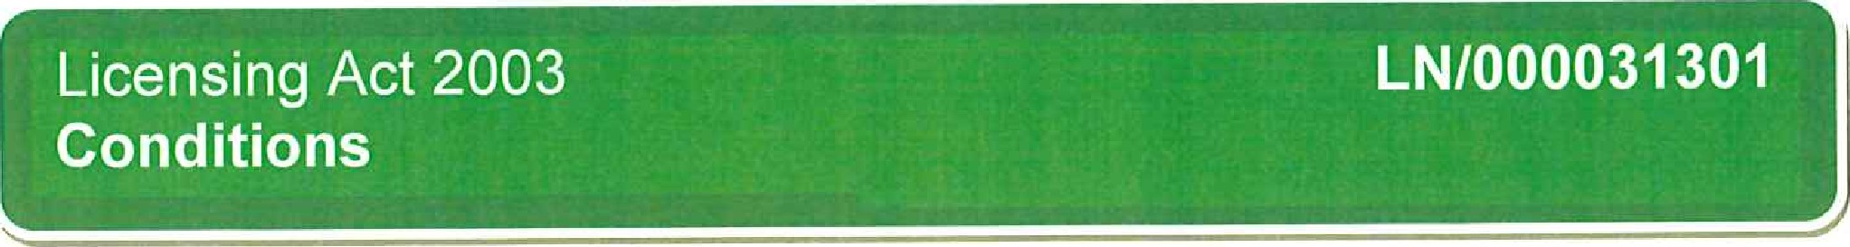
ANNEX 1 - MANDATORY CONDITIONS
Supplv of Alcohol
1, Where this Licence authorises the supply of alcohol:
No supply of alcohol may be made under this licence:
- At a time when there is no Designated Premises Supervisor in respect of the Premises Licence.
- At a time when the Designated Premises Supervisor does not hold a Personal Licence or his Personal Licence is suspended
Every retail sale or supply of alcohol made under this licence must be made or authorised by a person who holds a Personal Licence.
Exhibition of Films
Where a premises licence authorises the exhibition of films, the licence must include a condition requiring the admission of children to the exhibition of any film to be restricted in accordance with this section.
2 Where the film classification body is specified in the licencey unless subsection (3)(b) applies, admission of children must be restricted in accordance with any recommendation by that body.
3. Where:-
- The film classification body is not specified in the licence, or
- The relevant licensing authority has notified the holder of the licence that this subsection applies to the film in question; admission of children must be restricted in accordance with any recommendation made by that licensing authority.
4. In this section ['children" means any person aged under 18; and "film classification body" means the person or persons designated as the authority under Section 4 of the Video Recordings Act 1984(c39) (authority to determine suitability of video works for classification).
Irresponsible Promotions
I The responsible person must ensure that staff on relevant premises do not carry out, arrange or participate in any irresponsible promotions in relation to the premises.
2. In this paragraph, an irresponsible promotion means any one or more of the following activities, or
substantially similar activities, carried on for the purpose of encouraging the sale or supply of alcohol for consumption on the premises—
- games or other activities which require or encourage, or are designed to require or encourage, individuals to—.
drink a quantity of alcohol within a time limit (other than to drink alcohol sold or supplied on the premises before the cessation of the period in which the responsible person is authorised to sell or supply alcohol), or, drink as much alcohol as possible (whether within a time limit or otherwise);.
- provision of unlimited or unspecified quantities of alcohol free or for a fixed or discounted fee to the public or to a group defined by a particular characteristic in a manner which carries a significant risk of undermining a licensing objective;
- provision of free or discounted alcohol or any other thing as a prize to encourage or reward the purchase and consumption of alcohol over a period of 24 hours or less in a manner which carries a significant risk of undermining a licensing objective;
- selling or supplying alcohol in association with promotional posters or flyers on, or in the vicinity of, the premises which can reasonably be considered to condone encourage or glamorise anti-social behaviour or to refer to the effects of drunkenness in any favourable manner;
- dispensing alcohof directly by one person into the mouth of another (other than where that other person is unable to drink without assistance by reason of disabifity
Free Tap Water
1. The responsible person must ensure that free potable tap water is provided on request to customers where it is reasonably available. (This means that responsible persons at all premises must ensure customers are provided with potable (drinking) water for free if they ask for it.)

Age Verification Policy
- The premises licence holder or cfub premises certificate holder must ensure that an age verification policy is adopted in respect of the premises in relation to the sale or suppiy of alcohol.
- The designated premises supervisor in relation to the premises licence must ensure that the supply of alcohol at the premises is carried on in accordance with the age verification policy.
- The policy must require individuals who appear to the responsible person to be under 18 years of age (or such older age as may be specified in the policy) to produce on request, before being served alcohol, identification bearing their photograph, date of birth and either— a holographic mark, or. an ultraviolet feature.

Drink Volume Measures
1. The responsible person Shali ensure that:
- where any of the following alcoholic drinks is sold or supplied for consumption on the premises (other than alcoholic drinks sold or supplied having been made up in advance ready for sale or supply in a securely closed container) it is available to customers in *he following measures:
beer or cider: % pint; gin, rum, vodka or whisky: 25 ml or 35 ml; and still wine in a glass: 125 mi.
- these measures are displayed in a menu, price list or other printed material which is available to customers on the premises; and
- where a customer does not in relation to a sale of alcohol specify the quantity of alcohol to be sold, the customer is made aware that these measures are available.

Permitted Price
1 .
- A relevant person shall ensure that no alcohol is sold or supplied for consumption on or off the premises for a price which is less than the permitted price.
- For the purposes of the condition set out in paragraph 1—
- "duty" is to be construed in accordance with the Alcoholic Liquor Duties Act 1979;
- "permitted price" is the price found by applying the formula—

P is the permitted price*
ii. D is the amount of duty chargeable in relation to the alcohol as if the duty were charged on the date of the sale or supply of the alcohol, and iii. V is the rate of value added tax chargeable in relation to the alcohol as if the value added tax were charged on the date of the sale or supply of the alcohol;
- "relevant person" means, in relation to premises in respect of which there is in force a premises licence— the holder of the premises licence, the designated premises supervisor (if any) in respect of such a licence, or ii i. the personal licence holder who makes or authorises a supply of alcohol under such a licence;
- "relevant person" means, in relation to premises in respect of which there is in force a club premises certificate, any member or officer of the club present on the premises in a capacity which enables the member or officer to prevent the supply in question; and
- "value added tax" means value added tax charged in accordance with the Value Added Tax Act 1994.
2. Where the permitted price given by Paragraph B of paragraph 2 would (apart from this paragraph) not be a whole number of pennies, the price given by that sub-paragraph shall be taken to be the price actually given by that sub-paragraph rounded up to the nearest penny.
3.
(1) Sub.paragraph (2) applies where the permitted price given by Paragraph B of paragraph 2 on a day ("the first day") would be different from the permitted price on the next day ('the second day") as a result of a change to the rate of duty or value added tax.
(2)The permitted price which would apply on the first day applies to sales or supplies of alcohol which take place before the expiry of the period of 14 days beginning on the second day.
Door Supervision (except theatres. cinemas, bingo halls and casinos)
1 , Where a premises licence includes a condition that at specified times one or more individuals must be at the premises to carry out a security activity, each such individual must:
- be authorised to carry out that activity by a licence granted under the Private Security Industry Act 2001; or
- be entitled to carry out that activity by virtue of section 4 of the Act.
2. But nothing in subsection (1) requires such a condition to be imposed.
(a) in respect of premises within paragraph 8(3)(a) of Schedule 2 to the Private Security
Industry Act 2001 (c12) (premises with premises licences authorising plays or films); or (b) in respect of premises in relation to:
any occasion mentioned in paragraph 8(3)(b) or (c) of that Schedule (premises being used exclusively by club with club premises certificate, under a temporary event notice authorising ptays or films or under a gaming licence), or ii. any occasion within paragraph 8(3)(d) of that Schedule (occasions prescribed by regulations under that Act.
3, For the purposes of this section:
- "security activity" means an activity to which paragraph 2(1)(a) of that Schedule applies, and, which is licensable conduct for the purposes of that Act, (see Section 3(2) of that Act) and
- paragraph 8(5) of that Schedule (interpretation of references to an occasion) applies as it applies in relation to paragraph 8 of that Schedule.
ANNEX 2A - CONVERTED CONDITIONS
CONDITIONS CONSISTENT WITH THE OPERATING SCHEDULE
1, Staff to ensure that customers disperse without causing disturbance to residential property in the vicin ity
- Staff to report evidence of any criminal activity taking place on the premises to the Management and Police as soon as practicable
- All electrical, fire detection/alarms/lighting, gas appliances and any other relevant plant and equipment to be maintained in good working order and tested for such as necessary, Records of such checks to be maintained at the premises.
- Staff to ensure that there is no adverse impact or disturbance to other properties in the vicinity as a consequence of any licensable activity taking place at the premises
- Staff to be trained in their responsibilities with regard to alcohol sales and general safety of customers and staff within the premises
- If necessary to prevent under age drinking, introduce an appropriate proof of age identification scheme
- Staff to ensure that customers leave in such a manner as to not cause disturbance to other properties in the vicinity, particularly late at night
ANNEX 2B - OPERATfNG SCHEDULE
PREVENT\ON OF PUBLIC NUISANCE
  - None
PUBLIC SAFETY
  - None
PROTECTION OF CHILDREN FROM HARM
  - None
PREVENTION OF CRIME AND DISORDER
  - None
ANNEX 3 - CONDITIONS ATTACHED AFTER HEARING
None
ANNEX 4 - PLANS Attached Separately Dated: 31/03/22

NV"Id 00a a.NflOU
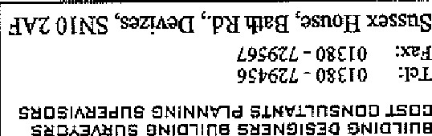
NVIN"IO(I
SNV1d 001
.LN3H3SV8 CNfiO
SNV1d 001  .LN3H3SV8 CNfiO |  | 
00 0 | S3Zlh30  NNI 390 8
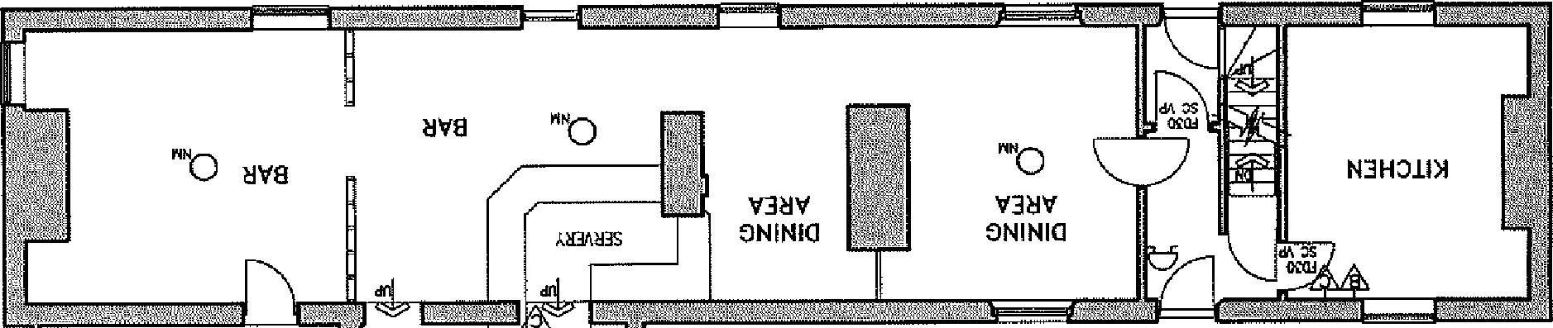
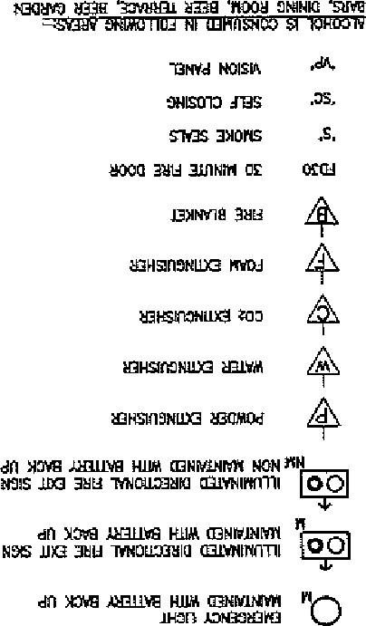
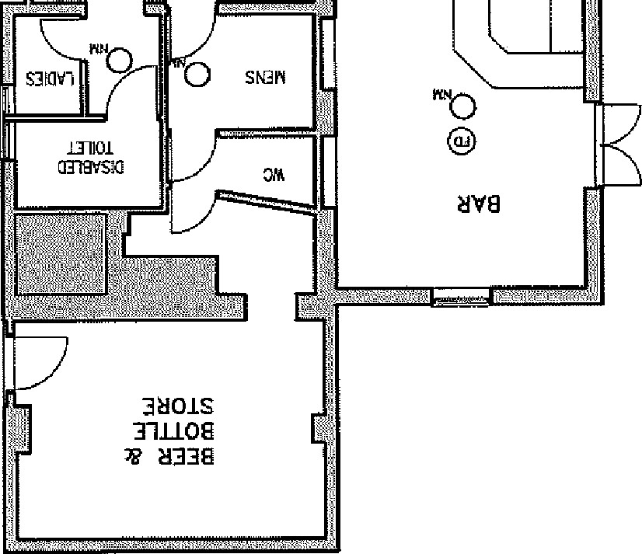
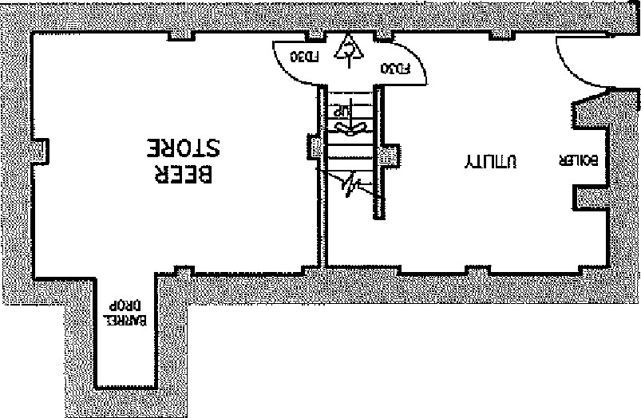
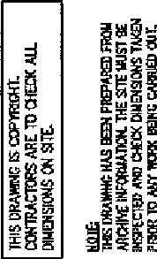
39VSSYd
NV-Id 00q INAVVRSVH S2EQV1
,12A11YG亠 NC
10 03 •*L.LWWNG -
-8ITO@
3 01S  31n08

